EXPERIMENT 3
EXPLORATORY DATA ANALYSIS (EDA) – DATA CLEANING AND DATA TRANSFORMATION

Aim
To identify and handle missing values, duplicate records, outliers, inconsistent data, and perform data transformation techniques such as normalization and encoding using Python Pandas.

Algorithm 1 – Missing Values
- Import Pandas.
- Load dataset.
- Check null values using isnull().
- Count missing values.

Program 1
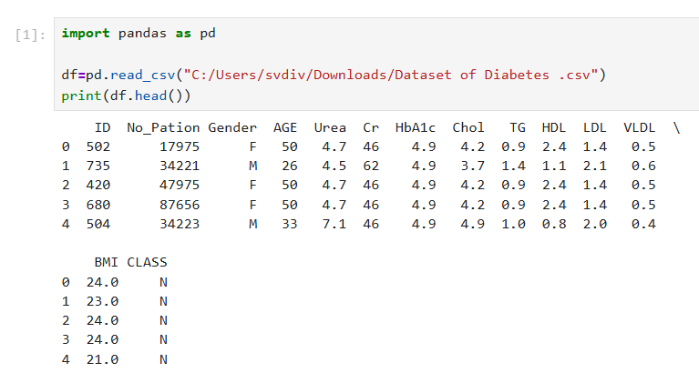

Algorithm 2 – Replace Missing Values
- Find numerical columns.
- Calculate mean.
- Replace null values.
- Verify.

Program 2
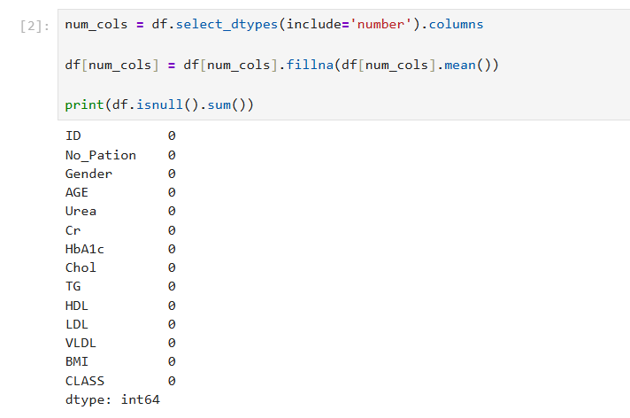
Algorithm 3 – Remove Duplicates
- Check duplicate records.
- Count duplicates.
- Remove duplicates.
- Display dataset.
Program 3
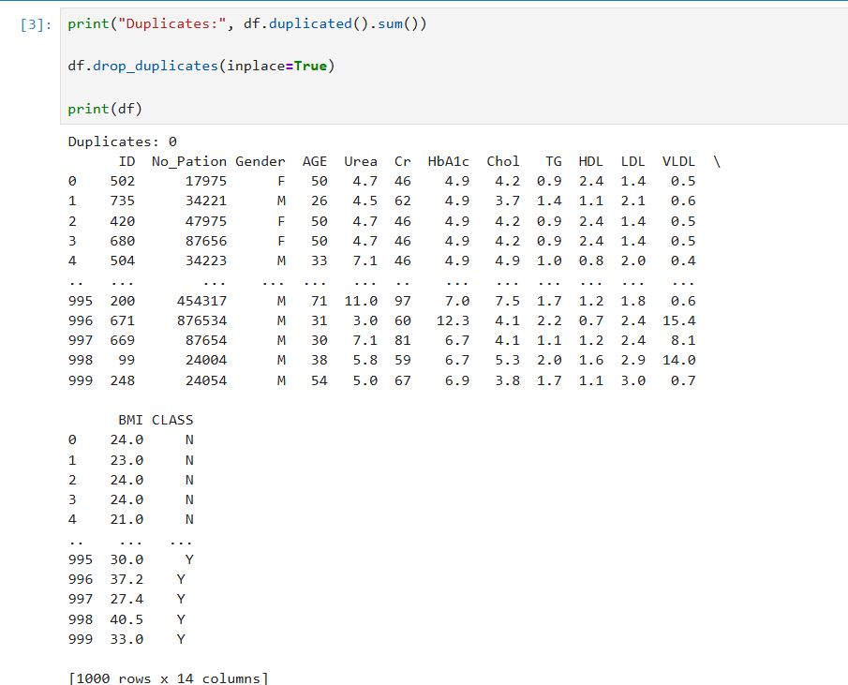
Algorithm 4 – Detect Outliers
- Calculate Q1 and Q3.
- Calculate IQR.
- Find lower and upper limits.
- Display outliers.
Program 4
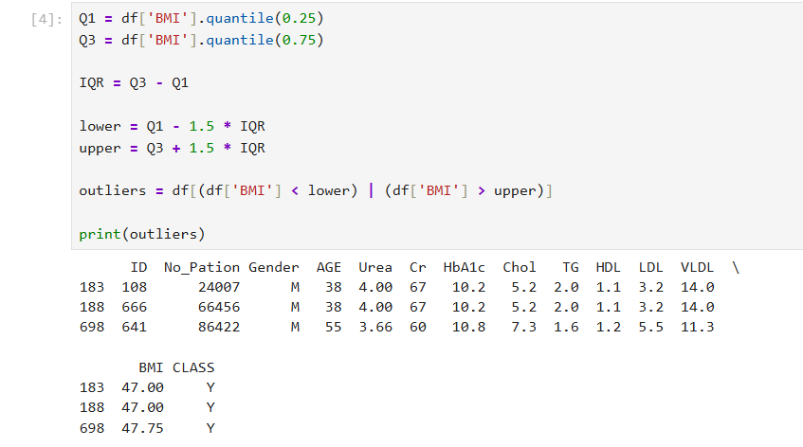
Algorithm 5 – Normalization
- Import MinMaxScaler.
- Select numerical columns.
- Apply normalization.
- Display result.
Program 5
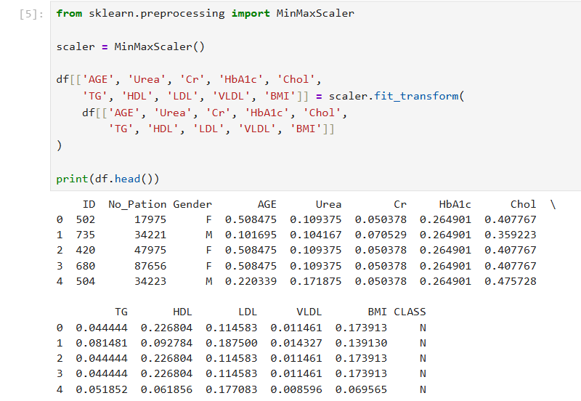
Algorithm 6 – Label Encoding
- Import LabelEncoder.
- Select categorical columns.
- Encode values.
- Display result.
Program 6
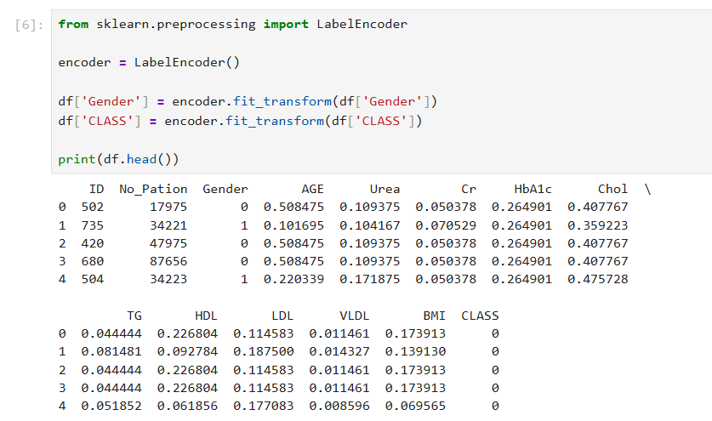

Result
Thus, missing values, duplicate records, and outliers were identified and handled successfully. Data transformation techniques such as normalization and encoding were performed, and the dataset was prepared for further exploratory data analysis and machine learning applications.

